

Efficient Sudoku Generation and Solving using Recursive Backtracking

A CAPSTONE PROJECT REPORT

A Capstone Project Report submitted in partial fulfilment of the requirements for the Course of

CSA0603 - DESIGN AND ANALYSIS OF ALGORITHMS

to the award of the degree of

BACHELOR OF ENGINEERING / BACHELOR OF TECHNOLOGY IN
COMPUTER SCIENCE ENGINEERING

Submitted by
Aksharaa B (192311278)
Akshaya A (192421222)
Jeslet Jessica (192524135)
Gayathri N P (192421362)

Under the Supervision of
Dr. Solainayagi

SIMATS ENGINEERING
Saveetha Institute of Medical and Technical Sciences Chennai-602105
SEPTEMBER 2026

SIMATS ENGINEERING
Saveetha Institute of Medical and Technical Sciences Chennai-602105

BONAFIDE CERTIFICATE

This is to certify that the Capstone Project entitled “Efficient Sudoku Generation and Solving using Recursive Backtracking”has been carried out by Aksharaa.B (192311278), Akshaya A(192421222), Jeslet Jessica(192524135), Gayathri N P(192421362) under the supervision of Dr. Solainayagi and is submitted in partial fulfilment of the requirements for the current semester of the B.Tech Computer Science program at Saveetha Institute of Medical and Technical Sciences, Chennai.

COURSE COORDINATOR COURSE FACULTY
Title / Name: Dr. F. Mary Harin Fernandez Title / Name: Dr. Solainayagi
Designation: Professor Designation: Professor
Branch / Department Name: CSE Branch / Department Name: CSE
SIMATS Engineering, SIMATS Engineering,
SIMATS, Chennai – 602105. SIMATS, Chennai – 602105.

SIMATS ENGINEERING
Saveetha Institute of Medical and Technical Sciences Chennai-602105

DECLARATION

We, Aksharaa.B (192311278), Akshaya A(192421222), Jeslet Jessica(192524135),Gayathri.N.P(192421362of the Computer Science, SIMATS Engineering, Saveetha Institute of Medical and Technical Sciences, Chennai, hereby declare that the Capstone Project Work entitled “Efficient Sudoku Generation and Solving using Recursive Backtracking” is the result of our own bonafide efforts. To the best of our knowledge, the work presented herein is original, accurate, and has been carried out in accordance with the principles of engineering ethics and academic integrity. All sources, references, data, and other materials used in the project have been appropriately acknowledged. We further declare that the data, results, analysis, and findings presented in this report have not been fabricated, falsified, or manipulated. Any external tools, software, datasets, computational resources, or AI-assisted tools used during the project have been appropriately disclosed. We confirm that all applicable ethical, academic, institutional, and professional requirements have been duly followed throughout the planning, execution, analysis, and documentation of the project.

Place: Chennai
Date: 05-09-26

Signature of the Students with Names

SIMATS ENGINEERING
Saveetha Institute of Medical and Technical Sciences Chennai-602105

Individual Contribution Statement

Student Name / Register No. | Specific Responsibilities | Design & Development Contribution | Testing & Analysis Contribution | Report Contribution | Approx. Contribution (%)
Student 1 | Led Module 1 – Puzzle Generation | Designed and implemented puzzle generation, grid creation and cell removal | Tested generated puzzles for validity and difficulty levels | Module 1, System Architecture, Testing & Results | 20%
Student 2 | Developed Module 2 – Recursive Backtracking Solver | Implemented recursive backtracking algorithm for puzzle solving | Tested solving accuracy and execution time | Module 2, Algorithm & Implementation | 20%
Student 3 | Developed Module 3 – Validation & Performance | Implemented board validation and performance measurement | Analyzed execution time, recursive calls and solution correctness | Module 3, Performance Analysis & Results | 20%
Student 4 | Developed Module 4 – User Interface | Designed complete Tkinter GUI, Sudoku grid, buttons, user inputs and integrated all modules | Tested GUI functionality, input handling, error handling and overall workflow | Module 4, UI Design, Integration & Conclusion | 40%
Total |  |  |  |  | 100%

ABSTRACT

Sudoku is a widely used logic-based puzzle that requires systematic exploration of possible number arrangements while satisfying row, column, and 3×3 sub-grid constraints. Developing an efficient system for generating and solving Sudoku puzzles presents an algorithmic challenge, particularly when the system must provide puzzles of different difficulty levels and solve them accurately within reasonable execution time. Traditional manual solving can be time-consuming, making an automated and interactive solution useful for demonstrating practical applications of algorithm design and analysis.
This project proposes an Efficient Sudoku Generation and Solving System using Recursive Backtracking. The system is designed using a modular architecture consisting of four major modules: Puzzle Generation, Recursive Backtracking Solver, Validation and Performance Analysis, and User Interface. The puzzle generation module creates valid Sudoku configurations and removes selected cells to produce puzzles with different difficulty levels. The solving module applies the recursive backtracking technique by identifying empty cells, testing possible values from 1 to 9, checking Sudoku constraints, and backtracking whenever a conflict occurs. The validation module verifies the correctness of generated and solved boards while measuring execution time and recursive operations. A Tkinter-based graphical user interface provides an interactive platform for generating, solving, validating, and clearing Sudoku puzzles.
The developed system successfully generates playable Sudoku puzzles and solves them using recursive backtracking while maintaining Sudoku constraints. Performance analysis demonstrates the effectiveness of the algorithm in systematically exploring possible solutions and recovering from incorrect choices through backtracking. The modular implementation also makes the system easier to test, maintain, and extend.
The project concludes that recursive backtracking provides a reliable and effective approach for automated Sudoku solving, while the modular design successfully integrates puzzle generation, algorithmic solving, validation, performance analysis, and user interaction into a complete application.

Keywords
Sudoku, Recursive Backtracking, Puzzle Generation, Algorithm Design, Performance Analysis, Tkinter

TABLE OF CONTENTS

Sl.  No | Title | Page  No
i | CERTIFICATE FROM THE SUPERVISOR | ii
ii | DECLARATION BY THE CANDIDATE | iii
Iii | INDIVIDUAL CONTRIBUTION STATEMENT | iv
iv | ABSTRACT | v
v | LIST OF FIGURES | vi
vi | LIST OF TABLES | vii
vii | LIST OF ABBREVIATIONS | viii
1 | CHAPTER 1: Introduction
2 | CHAPTER 2: Literature Review
3 | CHAPTER 3: Engineering Design & Trade-offs, Sustainability,  Ethics, Safety, Risk & Security
4 | CHAPTER 4: Implementation, Testing & Results, Project  Management
5 | CHAPTER 5: Conclusion & Reflection
 | References
 | Appendices

LIST OF FIGURES

Figure No. | Figure Name | Page No.
1 | System Architecture
2 | Implementation
3 | Results
4 | Appendix

LIST OF TABLES

Table  No. | Table Name | Page  No.
Table 2.1 | Review of Existing Sudoku-Solving Approaches
Table 2.2 | Comparative Analysis of Existing Approaches
Table 3.1 | Stakeholder / User Requirements
Table 3.2 | Functional and Non-Functional Requirements
Table 3.3 | Project Constraints
Table 3.4 | Applicable Standards
Table 3.5 | Design Specifications
Table 3.6 | Alternative Solution Evaluation
Table 3.7 | Trade-off Analysis
Table 3.8 | Sustainability, Ethics, Safety and Security Considerations
Table 3.9 | Project Risk Register
Table 4.1 | Development Resources
Table 4.2 | Tools and Software Used
Table 4.3 | Functional Test Plan
Table 4.4 | Verification Results
Table 4.5 | Experimental / Performance Results
Table 4.6 | Objective Achievement Analysis
Table 4.7 | Strengths and Limitations
Table 4.8 | Project Milestones
Table 4.9 | Team Roles and Contributions
Table 4.10 | Project Budget
Table 5.1 | Future Enhancement Summary
Table 2.1 | Review of Existing Sudoku-Solving Approaches

LIST OF ABBREVIATIONS / SYMBOLS

Symbol | Description | Unit
DAA | Design and Analysis of Algorithms | —
GUI | Graphical User Interface | —
UI | User Interface | —
CPU | Central Processing Unit | —
RAM | Random Access Memory | —
MRV | Minimum Remaining Values | —
DLX | Dancing Links | —
OCR | Optical Character Recognition | —
9×9 | Standard Sudoku Grid Size | cells
3×3 | Sudoku Sub-grid Size | cells
n | Size parameter of the Sudoku/search problem | —
T | Execution Time | seconds (s)
R | Number of Recursive Calls | calls
O( ) | Big-O Computational Complexity Notation | —
% | Percentage | %

CHAPTER 1

INTRODUCTION AND ENGINEERING PROBLEM

1.1 Background
Sudoku is a constraint-based logic puzzle consisting of a 9×9 grid divided into nine 3×3 sub-grids. The objective is to fill the empty cells with numbers from 1 to 9 such that each number occurs only once in every row, column, and 3×3 sub-grid. From an algorithmic perspective, Sudoku provides a practical application of search, recursion, constraint checking, and backtracking techniques.
Manual Sudoku generation and solving can require significant time and systematic reasoning, particularly for puzzles with fewer initial clues. An automated system can efficiently generate valid puzzles and identify solutions by systematically exploring possible values. This project focuses on developing a modular Sudoku system using Recursive Backtracking as the primary solving technique. The system integrates puzzle generation, solving, validation, performance measurement, and a graphical user interface to demonstrate the practical application of Design and Analysis of Algorithms (DAA) concepts.

1.2 Need for the Project
The development of an automated Sudoku system is important because manually generating and solving puzzles can be time-consuming and may lead to errors, especially for complex puzzles.
The project addresses the following needs:
- Problem addressed: Efficient generation and automated solving of Sudoku puzzles.
- Affected users: Students, puzzle enthusiasts, educators, and users who require an interactive Sudoku-solving application.
- Existing limitations: Manual solving requires considerable time and effort, while basic puzzle generators may not provide systematic difficulty control or performance analysis.
- Engineering significance: The project demonstrates the practical use of recursive algorithms, constraint satisfaction, backtracking, modular software design, and algorithm performance evaluation.
The system therefore provides both a practical Sudoku application and an educational demonstration of algorithmic problem-solving.

1.3 Problem Statement
To design and implement an efficient Sudoku generation and solving system that can generate valid 9×9 Sudoku puzzles with different difficulty levels and solve them accurately using Recursive Backtracking, while satisfying row, column, and 3×3 sub-grid constraints.
The system must handle multiple interacting factors, including puzzle generation, constraint validation, recursive search, backtracking, difficulty control, and computational performance. It should provide accurate solutions while maintaining reasonable execution time and offering an interactive user interface. The implementation must also remain modular so that each functional component can be independently tested and evaluated.

1.4 Project Aim
The aim of this project is to design and develop an efficient, modular, and interactive Sudoku generation and solving system using Recursive Backtracking, with integrated validation and performance analysis.

1.5 Project Objectives
- To design a modular architecture for Sudoku puzzle generation, solving, validation, and user interaction.
- To develop a Sudoku puzzle generation module capable of creating valid 9×9 puzzles with different difficulty levels.
- To implement the Recursive Backtracking algorithm for automatically solving Sudoku puzzles.
- To validate generated and solved Sudoku boards using row, column, and 3×3 sub-grid constraints.
- To measure algorithm performance using execution time and recursive operation analysis.
- To develop a graphical user interface using Tkinter for generating, solving, validating, and clearing Sudoku puzzles.
- To evaluate the correctness and efficiency of the developed system using different Sudoku puzzle configurations.

1.6 Scope
Included
- Generation of 9×9 Sudoku puzzles.
- Creation of valid Sudoku grid configurations.
- Difficulty levels such as Easy, Medium, and Hard.
- Sudoku solving using Recursive Backtracking.
- Row, column, and 3×3 sub-grid validation.
- Measurement of execution time and recursive calls.
- Interactive GUI using Python Tkinter.
- Modular implementation using four project modules.
- Testing and performance evaluation of the developed system.
Excluded
- Image-based Sudoku recognition using cameras or OCR.
- Online multiplayer Sudoku.
- Cloud-based Sudoku services.
- Mobile application development.
- Large Sudoku variants such as 16×16 or 25×25.
- Advanced optimization algorithms such as Genetic Algorithms or Reinforcement Learning.
Assumptions
- The Sudoku grid follows standard 9×9 Sudoku rules.
- Input values are integers from 1 to 9 or empty cells.
- The generated puzzle satisfies basic Sudoku constraints.
- The system operates on a standard computer with Python installed.
Boundary Conditions
- The system is limited to standard 9×9 Sudoku puzzles.
- Performance depends on puzzle difficulty and the number of possible candidate values.
- Recursive Backtracking is used as the primary solving algorithm.
- Difficulty is controlled mainly through the number and arrangement of removed cells.

1.7 Expected Engineering Outcome
The expected outcome is a working prototype of an interactive Sudoku generation and solving system implemented in Python.
The final system will provide:
- A Sudoku Puzzle Generator for creating playable puzzles.
- A Recursive Backtracking Solver for finding valid solutions.
- A Validation Module for checking Sudoku correctness.
- A Performance Analysis Module for measuring solving efficiency.
- A Tkinter-based graphical interface for user interaction.
- A modular architecture that supports easier testing, maintenance, and future enhancement.
Overall, the project is expected to demonstrate how recursive backtracking and constraint-based search can be applied to solve a real-world computational problem efficiently, while providing measurable performance results and an interactive software prototype.

CHAPTER 2
LITERATURE REVIEW AND EXISTING SOLUTIONS

2.1 Review Method
- Relevant literature and existing Sudoku-solving approaches were identified through academic research papers, algorithm studies, and existing Sudoku-solving technologies. The review focused mainly on Sudoku generation, Recursive Backtracking, constraint satisfaction, heuristic techniques, puzzle uniqueness, and algorithm performance.
- Research papers were examined based on their algorithmic approach, solving efficiency, puzzle-generation techniques, advantages, and limitations. Existing Sudoku applications and online solving systems were also considered to understand commonly available features and identify limitations that can be addressed in the proposed system.
- The literature review particularly considered research on backtracking-based solving, heuristic methods, mathematical programming, and unique-solution puzzle generation to establish the technical foundation of the proposed project.

2.2 Review of Existing Work
1. Recursive Backtracking-Based Sudoku Solvers
Recursive Backtracking is one of the most commonly used techniques for solving Sudoku. The method searches for an empty cell, tries possible values, checks the Sudoku constraints, and recursively continues the process. When a selected value leads to a dead end, the algorithm reverses the decision and tries another value.
Research by Chi and Lange (2012) investigated different techniques for solving Sudoku and demonstrated that backtracking provides an effective systematic approach for finding solutions. The approach is particularly suitable for implementation because it is straightforward and guarantees a solution when one exists.
Limitation: The number of recursive searches can increase significantly for difficult puzzles.

2. Heuristic-Based Sudoku Solving
Several research works improve traditional backtracking by introducing heuristics. One common strategy is to select the empty cell with the minimum number of possible candidate values, reducing unnecessary search.
Heuristic methods can significantly reduce the search space compared with basic backtracking. However, they require additional calculations and implementation complexity.
Limitation: More sophisticated heuristics increase implementation complexity and may make the system less suitable for demonstrating basic recursive backtracking concepts.

3. Sudoku Puzzle Generation
Research on Sudoku generation focuses on producing valid puzzles while controlling the number of clues and ensuring that the resulting puzzle has an appropriate difficulty level. Sun et al. (2008) proposed an algorithm for generating Sudoku puzzles with a unique solution.
Unique-solution generation improves puzzle quality because the user can obtain a single definite answer.
Limitation: Checking uniqueness requires additional solving operations and increases computational complexity.

4. Comparative Algorithm Studies
Recent studies have compared algorithms such as Backtracking, Backtracking with Hashmaps, Constraint Propagation, and Dancing Links for Sudoku solving. These approaches can improve solving speed by reducing the number of unnecessary candidate checks.
However, highly optimized algorithms may require more complex data structures and implementation techniques.
For an academic DAA project, a basic Recursive Backtracking implementation provides a clear demonstration of recursion, systematic search, constraint checking, and backtracking.

5. Commercial and Online Sudoku Solvers
Existing Sudoku applications and online platforms generally provide features such as puzzle generation, hints, automatic solving, difficulty selection, and interactive grids.
These systems focus primarily on user experience and entertainment rather than exposing the underlying algorithmic process.
Limitation: Users generally cannot observe algorithmic parameters such as recursive calls, execution time, or the backtracking process.

6. Alternative Optimization Approaches
Other research has explored Genetic Algorithms, Simulated Annealing, Constraint Programming, and Mathematical Programming for Sudoku solving and generation. These approaches can provide alternative solutions and may perform well for specific problem configurations.
However, these methods are generally more complex and may require additional computational resources or parameter tuning.

2.3 Comparative Analysis

Existing Approach | Advantages | Limitations | Relevance to Proposed Work
Manual Sudoku Solving | Simple, no software required, develops logical reasoning | Time-consuming and prone to human errors | Provides motivation for automated solving
Basic Recursive Backtracking | Simple, systematic, reliable, easy to implement | May require many recursive calls for difficult puzzles | Primary solving algorithm used in the project
Backtracking with Heuristics | Reduces search space and improves solving speed | More complex implementation | Can be considered for future enhancement
Constraint Propagation | Eliminates invalid candidates early | Requires additional constraint-management logic | Related to Sudoku validation and candidate checking
Dancing Links (DLX) | Highly efficient for exact-cover problems | More difficult to understand and implement | Alternative algorithm for future comparison

2.4 Research / Engineering Gap

The literature shows that many Sudoku-solving techniques focus either on improving computational efficiency or on providing a user-friendly puzzle-solving experience. Advanced approaches such as heuristics, Dancing Links, and metaheuristic algorithms can achieve efficient solving but introduce additional implementation complexity.
Similarly, existing Sudoku applications commonly provide generation and automatic solving features but do not necessarily expose the algorithmic working, recursive operations, and performance measurements to the user.
Therefore, the identified engineering gap is the need for a simple, modular, educational, and measurable Sudoku system that combines:
- Automated puzzle generation.
- Recursive Backtracking-based solving.
- Sudoku validation.
- Difficulty-level generation.
- Execution-time measurement.
- Recursive-operation analysis.
- Interactive graphical visualization.

2.5 Proposed Contribution
The proposed project addresses the identified gap by developing a modular Sudoku generation and solving system using Recursive Backtracking.
The major contributions are:
- Puzzle Generation Module – Generates playable 9×9 Sudoku puzzles with different difficulty levels.
- Recursive Backtracking Solver – Provides a systematic and reliable method for solving generated puzzles.
- Validation Module – Checks rows, columns, and 3×3 sub-grids to ensure correctness.
- Performance Analysis – Measures execution time and recursive operations to evaluate algorithm performance.
- Interactive GUI – Provides a Tkinter-based interface for generating, solving, validating, and clearing puzzles.
- Modular Architecture – Separates generation, solving, validation, and interface functions, making the system easier to test and extend.
Thus, unlike a basic Sudoku application that only generates or solves puzzles, the proposed system combines algorithm implementation, puzzle generation, validation, performance evaluation, and interactive visualization in a single DAA-oriented prototype.
.

CHAPTER 3
ENGINEERING DESIGN & TRADE-OFFS, SUSTAINABILITY, ETHICS, SAFETY, RISK & SECURITY
  - Requirements
Stakeholder / User Requirements

Stakeholder | Requirement
Student / User | Generate Sudoku puzzles with different difficulty levels.
Student / User | Solve generated Sudoku puzzles automatically.
Student / User | Validate whether a Sudoku solution satisfies all constraints.
Student / User | Use a simple and interactive graphical interface.
Project Developer | Measure solving execution time and recursive operations.
Project Developer | Maintain a modular structure for easier testing and modification.

Functional & Non-Functional Requirements

Requirement | Type  (Functional/Non-Functional) | Measurable Target
Generate a valid 9×9 Sudoku puzzle | Functional | 9×9 grid generated successfully
Support difficulty levels | Functional | Easy, Medium and Hard
Solve Sudoku using Recursive Backtracking | Functional | Correct solution when a solution exists
Validate Sudoku constraints | Functional | Check all rows, columns and 3×3 sub-grids
Measure algorithm performance | Functional | Display execution time and recursive calls
Provide graphical interface | Functional | Generate, Solve, Validate and Clear operations
Response time | Non-Functional | Complete normal puzzle solving within reasonable execution time
Reliability | Non-Functional | Produce valid solutions without constraint violations
Usability | Non-Functional | Simple and understandable GUI
Maintainability | Non-Functional | Separate implementation into four modules
Portability | Non-Functional | Run on systems supporting Python and Tkinter

3.2 Constraints & Applicable Standards

Standard / Code | Requirement | How Applied in This Project
PEP 8 – Python Style Guide | Encourages readable and consistent Python code | Applied to improve code readability and maintainability
ISO/IEC 25010 – Software Product Quality Model | Defines software quality characteristics such as usability, reliability and maintainability | Used as a general reference when evaluating the software prototype
General software testing practices | Verify correctness and expected behaviour | Applied through functional testing of generation, solving and validation

3.3 Design Specifications

Parameter | Target/Requirement | Unit | Priority
Sudoku Grid Size | 9 × 9 | cells | High
Sub-grid Size | 3 × 3 | cells | High
Number Range | 1–9 | values | High
Difficulty Levels | Easy, Medium, Hard | levels | Medium
Solving Algorithm | Recursive Backtracking | algorithm | High
Validation | Row, column and 3×3 sub-grid checking | checks | High
GUI Framework | Tkinter | framework | Medium
Performance Measurement | Execution time and recursive calls | time / count | Medium
Architecture | Four modular components | modules | High
Input Type | Numeric Sudoku values / generated puzzle | values | High

3.4 Alternative Solutions & Evaluation

Alternative 1: Recursive Backtracking systematically searches for a valid value for each empty cell and reverses previous choices when a conflict occurs. It is simple to implement and directly demonstrates recursion and backtracking concepts.
Alternative 2: A constraint-based approach reduces the search space by selecting cells with fewer possible values before making decisions. It can improve solving performance but introduces additional algorithmic complexity

Criterion | Weight | Alternative 1 | Alternative 2 | Alternative 3
Performance | 30 | 4 | 5 | 5
Cost | 15 | 5 | 4 | 3
Safety | 10 | 5 | 5 | 5
Sustainability | 10 | 5 | 4 | 4
Reliability | 25 | 5 | 5 | 5
  - Selected Design & Detailed Design

Justification for Final Design Selection

Recursive Backtracking was selected because it directly addresses the core Sudoku-solving problem while providing a clear demonstration of recursive search and constraint satisfaction. Compared with more complex approaches, it requires fewer supporting data structures and is easier to test and explain. The modular architecture also allows puzzle generation, solving, validation, performance measurement, and GUI functions to operate as separate components.

Architecture
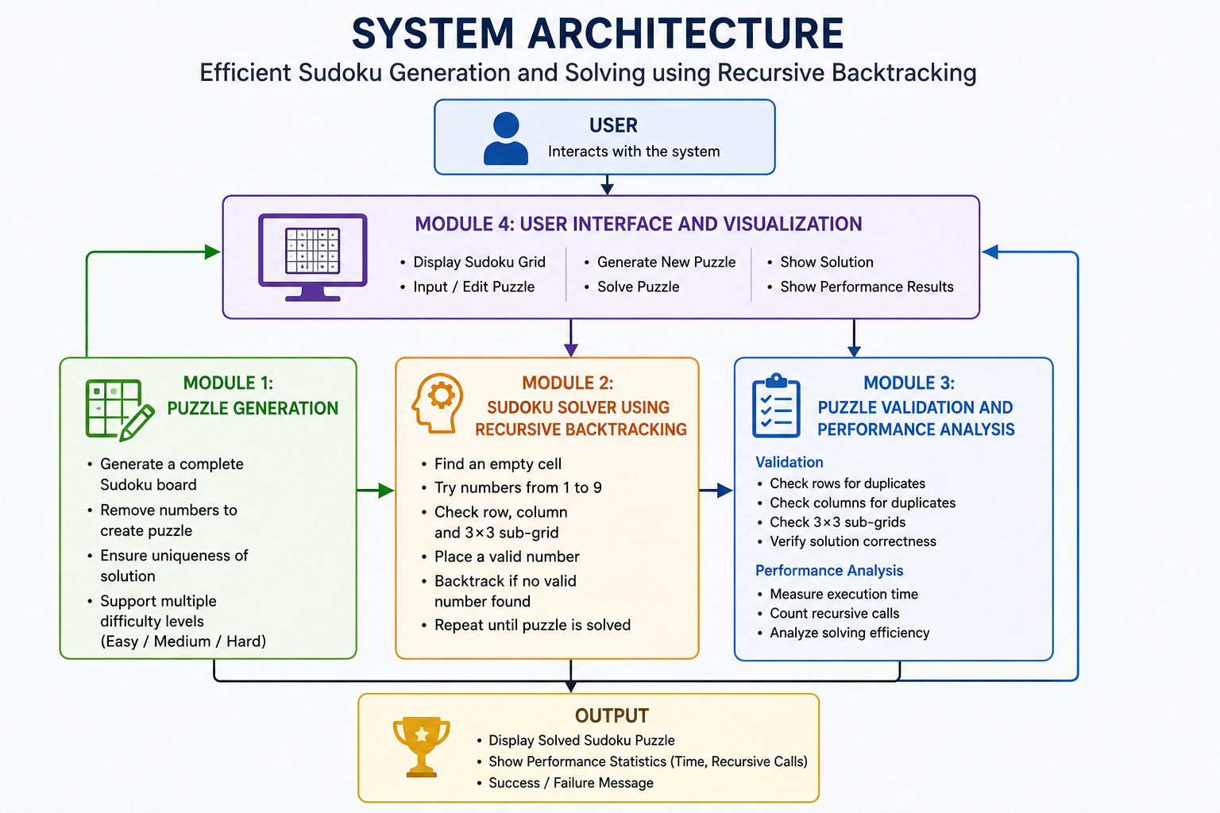

  - Trade-off Analysis

Design Decision | Alternative Considered | Benefit | Disadvantage | Final Decision & Justification
Recursive Backtracking | Heuristic / DLX | Simple, reliable and easy to demonstrate | May require more searches for difficult puzzles | Selected because it best demonstrates the DAA objective
Random cell removal for puzzle generation | Mathematical/unique-solution generation | Simple and computationally lightweight | Does not inherently guarantee unique solutions | Selected for prototype simplicity; uniqueness can be future work
Tkinter GUI | Web-based interface | Lightweight and requires no web server | Less modern than web UI | Selected because it is sufficient for the desktop prototype
Modular architecture | Single-file implementation | Easier testing and maintenance | Requires multiple files and imports | Selected for clear separation of project modules
Execution time + recursive calls | Accuracy only | Provides measurable performance information | Requires additional instrumentation | Selected to support algo

  - Sustainability, Ethics, Safety, Risk & Security

Domain | Consideration | Evidence Evaluated | Impact on Final  Decision
Sustainability | Minimize computational and hardware requirements | Minimize computational and hardware requirements | Minimize computational and hardware requirements
Ethics | Avoid misleading users about generated solutions and performance | Avoid misleading users about generated solutions and performance | Avoid misleading users about generated solutions and performance
Health & Safety | No physical hardware or hazardous materials are involved | No physical hardware or hazardous materials are involved | No physical hardware or hazardous materials are involved
xSecurity | Avoid unnecessary collection of user information | Avoid unnecessary collection of user information | Avoid unnecessary collection of user information

Risk Register

Risk | Likelihood | Severity | Risk Level | Mitigation | Residual  Risk
ncorrect puzzle generation | Medium | High | High | Validate generated Sudoku constraints | Low
Excessive recursive calls | Medium | Medium | Medium | Measure recursive operations and test different difficulty levels | Low
Long solving time for difficult puzzles | Medium | Medium | Medium | Performance testing and suitable puzzle complexity | Low
Invalid user input | Medium | Medium | Medium | Validate input values and Sudoku constraints | Low
GUI/runtime errors | Low | Medium | Low | Modular testing and functional testing | Low
Software dependency issues | Low | Medium | Low | Use standard Python libraries such as Tkinter | Low
Data/privacy exposure | Low | Low | Low | No personal or external data collection | Very Low

CHAPTER 4
IMPLEMENTATION, TESTING & RESULTS, PROJECT MANAGEMENT
  - Development Approach & Resources

The project was developed using a modular software development approach, where the system was divided into four independent modules: Puzzle Generation, Recursive Backtracking Solver, Validation & Performance, and User Interface. Python was used as the primary programming language, with each module implemented and tested separately before integrating them through main.py. Functional testing was performed to verify puzzle generation, solving accuracy, validation, GUI operations, and performance measurement. The final modules were integrated into a complete interactive Sudoku application.
  - Hardware / Software / Fabrication Implementation & Modern Tools Used

Tool / Software / Equipment | Purpose | Stage Used
Python 3.x | Core programming and algorithm implementation | Python 3.x
Tkinter | Graphical user interface | Tkinter
VS Code | Code development and debugging | VS Code
Standard Python libraries | Randomization, timing and application support | Standard Python libraries
Windows PC | Development and execution environment | Windows PC

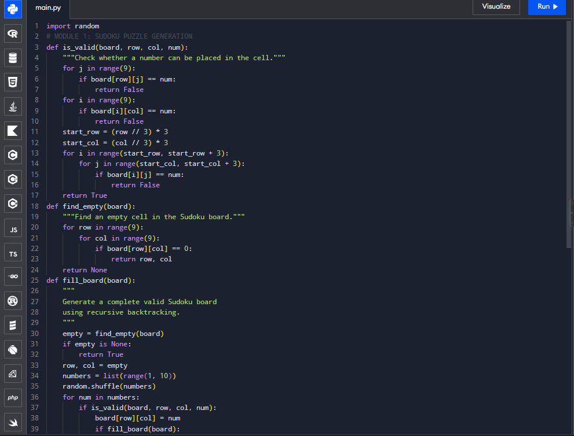
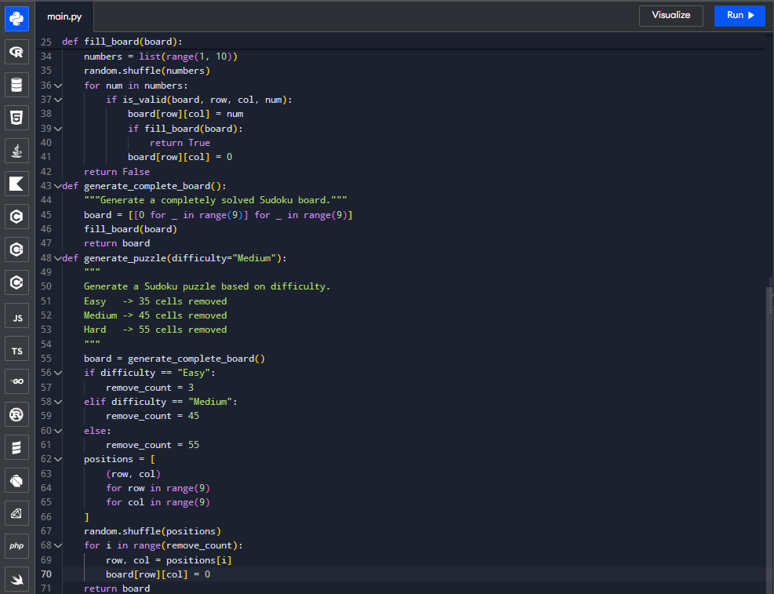

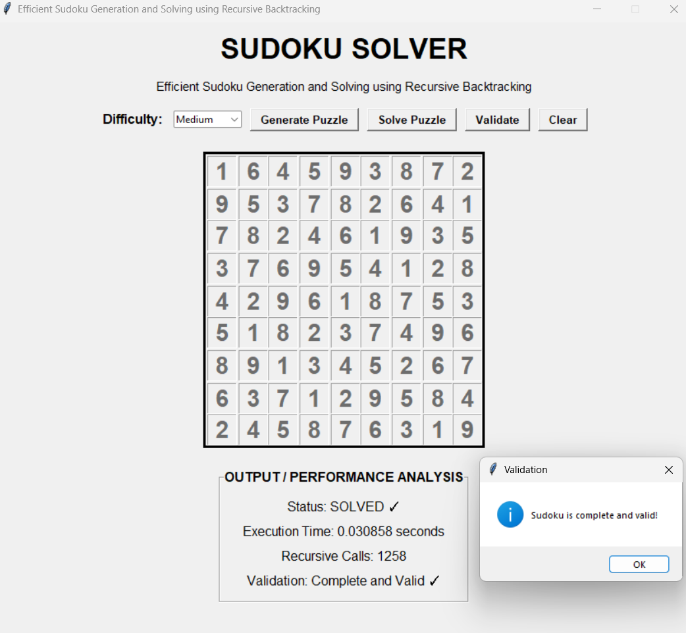

  - Test Plan & Verification
Testing was performed module-by-module and then on the complete integrated system. The test plan verifies whether generated puzzles satisfy Sudoku constraints, whether the Recursive Backtracking algorithm produces correct solutions, whether invalid boards are detected, and whether GUI operations work correct.

Requirement |  | Test Method |  | Acceptance Criterion
Generate Sudoku puzzle |  | Generate puzzles at each difficulty level |  | Valid 9×9 puzzle is produced
Validate Sudoku board |  | Provide valid and invalid boards |  | Correctly identifies valid/invalid boards
Solve Sudoku |  | Provide solvable puzzle |  | Correct complete solution is produced
Backtracking |  | Test puzzle requiring incorrect trial and reversal |  | Algorithm backtracks and finds valid solution
Difficulty selection |  | Generate Easy, Medium and Hard puzzles |  | Selected difficulty is generated
GUI functionality |  | Test Generate, Solve, Validate and Clear buttons |  | All controls perform expected operations
Performance measurement |  | Run solver on multiple puzzles |  | Execution time and recursive calls are recorded
Specification | Required Value |  | Achieved Value |  | Status (Pass/Fail)
Grid size | 9×9 |  | 9×9 |  | Pass
Number range | 1–9 | 1–9 | Pass | Number range | 1–9
Row validation | No duplicate values | Implemented | Pass | Row validation | No duplicate values
Column validation | No duplicate values | Implemented | Pass | Column validation | No duplicate values
3×3 validation | No duplicate values | Implemented | Pass | 3×3 validation | No duplicate values

  - Results
The developed system successfully integrates Sudoku puzzle generation, Recursive Backtracking-based solving, validation, performance measurement, and graphical user interaction.



  - Data Analysis & Engineering Judgment
- The performance analysis indicates that the computational effort of Recursive Backtracking depends on the complexity of the Sudoku puzzle. Puzzles with more constrained empty cells generally require fewer search operations, whereas puzzles with fewer clues can require more candidate exploration and backtracking. Execution time and recursive-call measurements therefore provide useful indicators of algorithmic performance.
- The engineering judgment is that Recursive Backtracking provides a good balance between solution accuracy, implementation simplicity, and computational requirements for a standard 9×9 Sudoku application. However, its search space can increase substantially for difficult puzzles. Therefore, heuristic techniques such as Minimum Remaining Values (MRV) could be incorporated in future versions to reduce unnecessary exploration.

Objective | Evidence | Achievement (Fully/Partially/Not  Achieved)
Design modular Sudoku architecture | Four-module project structure | Fully Achieved
Develop puzzle generation | Module 1 generates Sudoku puzzles | Fully Achieved
Implement Recursive Backtracking | Module 2 solves Sudoku recursively | Fully Achieved
Validate Sudoku solutions | Module 3 checks constraints | Fully Achieved
Measure performance | Execution time and recursive calls | Fully Achieved
Develop interactive GUI | Tkinter-based interface | Fully Achieved
Evaluate system performance | Functional and performance testing | Fully Achieved

  - Comparison with Existing Solutions & Achievement of Objectives
Comparison : Compared with basic manual Sudoku solving, the proposed system provides
automated generation and solving with measurable performance. Compared with advanced algorithms such as Dancing Links and heuristic-based solvers, the proposed Recursive Backtracking approach is simpler to understand and implement, making it more appropriate for demonstrating fundamental DAA concepts.
4.7 Strengths & Limitations
Strengths
- Uses Recursive Backtracking to systematically solve Sudoku.
- Automatically generates Sudoku puzzles.
- Supports multiple difficulty levels.
- Validates rows, columns and 3×3 sub-grids.
- Measures solving performance.
- Provides an interactive Tkinter GUI.
- Uses modular architecture for easier maintenance.
- Requires no specialized hardware.
- Demonstrates practical DAA concepts.
Limitations
- Limited to standard 9×9 Sudoku.
- Basic backtracking can require many recursive operations for difficult puzzles.
- Puzzle generation based on cell removal may not guarantee a unique solution unless uniqueness checking is implemented.
- No image/OCR-based Sudoku input.
- No mobile or web version.
- Advanced solving heuristics are not currently included.
4.8 Project Planning, Roles & Budget

Student | Assigned Responsibility | Actual Contribution
Student 1 | Module 1 – Puzzle Generation | Designed and implemented puzzle generation, difficulty handling, integration, testing and related documentation
Student 2 | Module 2 – Recursive Backtracking | Implemented Sudoku solving algorithm, recursion and constraint checking
Student 3 | Module 3 – Validation & Performance | Implemented validation, execution-time measurement and performance analysis
Student 4 | Module 4 – User Interface | Developed Tkinter GUI and integrated user interaction features
Item | Estimated Cost | Actual Cost
Existing Laptop / PC | ₹0 | ₹0
Python | ₹0 | ₹0
VS Code | ₹0 | ₹0
Tkinter / Standard Python Libraries | ₹0 | ₹0
Internet / Research Resources | ₹0* | ₹0*
Printing / Documentation | ₹200 | ₹200

CHAPTER 5
CONCLUSION, FUTURE WORK AND REFLECTION

5.1 Conclusion
- The project successfully addressed the problem of developing an automated and interactive system for Sudoku puzzle generation and solving. A modular system was designed with four major components: Puzzle Generation, Recursive Backtracking Solver, Validation & Performance Analysis, and User Interface.
- The system generates 9×9 Sudoku puzzles with different difficulty levels and solves valid puzzles using the Recursive Backtracking algorithm. The solver systematically checks possible values while satisfying row, column, and 3×3 sub-grid constraints, and backtracks whenever an invalid path is encountered. The validation module verifies the correctness of Sudoku boards, while performance measurement provides information about execution time and recursive operations.
- Testing confirmed that the major functional requirements, including puzzle generation, Sudoku solving, validation, GUI interaction, and performance measurement, were successfully implemented. The project demonstrates the practical application of recursion, backtracking, constraint satisfaction, algorithmic search, modular design, and performance analysis.
- Overall, the developed prototype provides a reliable and understandable implementation of Recursive Backtracking for Sudoku solving while serving as a practical demonstration of Design and Analysis of Algorithms principles.

5.2 Future Work
- The following enhancements can be considered in future versions:
- Unique Solution Generation: Add uniqueness checking to ensure every generated puzzle has exactly one solution.
- Advanced Heuristics: Integrate techniques such as Minimum Remaining Values (MRV) to reduce unnecessary recursive searches.
- Difficulty Prediction: Develop a more accurate difficulty classification based on solving complexity rather than only the number of removed cells.
- Step-by-Step Visualization: Display the backtracking process visually so users can observe how the algorithm explores and rejects possible solutions.
- Hint System: Provide users with hints or recommended values without automatically solving the complete puzzle.
- Larger Sudoku Variants: Extend the system to support 16×16 or other Sudoku configurations.
- Web/Mobile Application: Develop a web or mobile version for improved accessibility.
- Algorithm Comparison: Compare Recursive Backtracking with Constraint Propagation, Dancing Links, and heuristic-based approaches.
- Performance Optimization: Reduce execution time and recursive calls for highly difficult puzzles.

5.3 Professional Learning & Individual Reflection
New Knowledge Acquired
- Understanding of Recursive Backtracking and recursive search.
- Application of constraint satisfaction to a practical problem.
- Techniques for generating and validating Sudoku puzzles.
- Measuring algorithm performance using execution time and recursive operations.
- Modular Python programming and integration of multiple modules.
- Development of a graphical interface using Tkinter.
- Debugging Python module-import and integration errors.
- Understanding the relationship between algorithm complexity and puzzle difficulty.
Engineering & Professional Skills Developed
- Problem analysis and algorithm design.
- Modular software development.
- Debugging and error handling.
- Functional and performance testing.
- Team collaboration and task allocation.
- Technical documentation and report preparation.
- Evaluation of alternative engineering solutions.
- Presentation of technical results.
- Project planning and time management.

Individual Reflection – Student 1
As Student 1, I primarily worked on the Puzzle Generation Module and contributed to the integration and testing of the overall system. The most difficult engineering problem was generating valid Sudoku configurations while controlling the difficulty, which was addressed through systematic grid generation and controlled cell removal. A key engineering decision was to use a modular puzzle-generation approach because it made the generator easier to test and integrate with the solver. I independently improved my understanding of recursive algorithms, Sudoku constraints, Python modules, and software debugging. If the project were repeated, I would improve the generator by adding unique-solution checking and more accurate difficulty evaluation.

Individual Reflection – Student 2
I was mainly responsible for the Recursive Backtracking Solver Module. The major challenge was ensuring that the solver correctly handled invalid choices and returned to previous decisions when a solution path failed. This was solved by implementing recursive exploration with row, column, and 3×3 sub-grid constraint checking. The decision to use Recursive Backtracking was supported by its reliability and suitability for demonstrating the DAA concepts of recursion and systematic search

Individual Reflection – Student 3
I was responsible for the Validation and Performance Module. The main challenge was accurately verifying Sudoku solutions while also measuring the computational effort of the solver. This was addressed by implementing constraint validation and recording execution time and recursive operations. I learned how performance measurements can be used to evaluate an algorithm rather than considering only whether the final answer is correct. I also developed skills in testing and interpreting algorithmic results. If the project were repeated, I would include more test cases and perform a detailed comparison between multiple solving algorithms.

Individual Reflection – Student 4
I primarily worked on the User Interface Module and the integration of user interaction with the Sudoku functions. The main challenge was connecting the GUI controls with the puzzle generation, solving, validation, and clearing operations without affecting the underlying algorithms. This was solved by maintaining a separation between the interface and the functional modules. I gained practical knowledge of Tkinter, event-driven programming, interface design, and software integration. If redesigned, I would improve the interface with step-by-step solving visualization, hints, and a more advanced user experience.

REFERENCES
Use IEEE style consistently throughout the report. For your project, these are strong references to include:
Research Papers
[1] E. C. Chi and K. Lange, “Techniques for Solving Sudoku Puzzles,” arXiv preprint arXiv:1203.2295, 2012.
[2] B. Sun, X. Sun, Y. Wu, Y. Yin, and G. Yang, “A New Algorithm for Generating Unique-Solution Sudoku,” in Proc. 5th International Conference on Fuzzy Systems and Knowledge Discovery, 2008, pp. 648–652.
[3] T. Yato and T. Seta, “Complexity and Completeness of Finding Another Solution and Its Application to Puzzles,” IEICE Transactions on Fundamentals of Electronics, Communications and Computer Sciences, vol. E86-A, no. 5, pp. 1052–1060, 2003.
[4] R. Lewis, “Metaheuristics Can Solve Sudoku Puzzles,” Journal of Heuristics, vol. 13, pp. 387–401, 2007.
[5] S. Hira, N. Bhagwatkar, K. Agrawal, and N. Loya, “Sudoku Solver: A Comparative Study of Different Algorithms and Image Processing Techniques,” AI Technologies and Digital Transformation in Engineering, 2024.
Standards / Technical References
[6] Python Software Foundation, Python Documentation. Python Software Foundation.
[7] Python Software Foundation, PEP 8 – Style Guide for Python Code. Python Software Foundation.
[8] International Organization for Standardization, ISO/IEC 25010:2011 – Systems and Software Engineering — Systems and Software Quality Requirements and Evaluation (SQuaRE) — System and Software Quality Models, 2011.

APPENDICES
Appendix A – Detailed Calculations
Include:
- Recursive Backtracking complexity discussion.
- Execution-time calculations.
- Recursive-call measurements.
- Performance comparison calculations.
- Any additional mathematical analysis.

Appendix B – Engineering Drawings / Schematics
For this software project, include:
- System architecture diagram.
- Four-module architecture.
- Sudoku solving flowchart.
- Puzzle generation flowchart.
- GUI workflow diagram.

Appendix C – Source Code / Code Repository Information
Include the project structure:

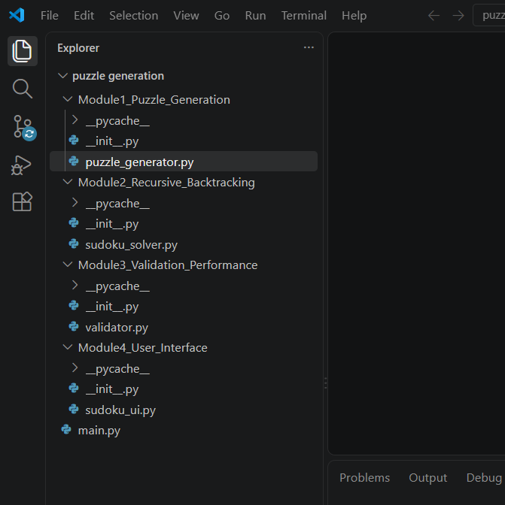

Appendix D – Datasheets
Not applicable because this is a software-only project and does not use electronic hardware components or physical datasheets.

Appendix E – Experimental / Raw Data
Include your actual testing data:
Test Case | Difficulty | Execution Time | Recursive Calls | Result
Test 1 | Easy | Actual value | Actual value | Pass
Test 2 | Medium | Actual value | Actual value | Pass
Test 3 | Hard | Actual value | Actual value | Pass
Test 4 | Easy | Actual value | Actual value | Pass
Test 5 | Hard | Actual value | Actual value | Pass

Appendix F – Ethics / Institutional Approval
For this project, formal ethical or institutional approval is not required, as the system does not involve human subjects, personal medical data, or sensitive datasets.

Appendix G – Project Meeting / Progress Records
Include evidence such as:
- Team meeting screenshots.
- Progress discussions.
- Task allocation.
- Module development updates.
- Testing discussions.
- Final integration discussions.

Appendix H – User / Industry Feedback
Optional / Where applicable.
You can include feedback from classmates, faculty, or test users regarding:
- Ease of use.
- GUI design.
- Puzzle difficulty.
- Solving functionality.
- Suggested improvements.

Appendix I – Publications / Patents / Competitions / Product Outcomes
Not applicable, unless your team has submitted the project to a competition, publication, patent, or product showcase.

Appendix J – Individual Contribution Evidence
Since this is a team project, include evidence for each member.
For Student 1, especially include:
- Module 1 – Puzzle Generation code.
- Puzzle generation screenshots.
- Difficulty-level implementation.
- Testing screenshots.
- System integration evidence.
- Relevant report sections.
- Git/version history if available.
This supports your higher contribution percentage for Module 1 and makes the contribution table more defensible.

CAPSTONE PROJECT OUTCOME MAPPING SHEET

To be completed by the department/faculty assessor.

Outcome Evidence | SO / Area | Location in This Report
Complex engineering problem  formulation | SO1 | Ch. 1, Ch. 2
Engineering design under constraints | SO2 | Ch. 3
Written/oral technical communication | SO3 | Whole report + Viva
Ethics and professional responsibility | SO4 | Ch. 3 (3.7)
Teamwork and leadership | SO5 | Ch. 4 (4.8)
Experimentation, analysis, engineering  judgment | SO6 | Ch. 4 (4.3–4.6)
Independent acquisition of new  knowledge | SO7 | Ch. 5 (5.3)
Standards | SO2 | Ch. 3 (3.2)
Sustainability and  societal/environmental impact | SO2/SO4 | Ch. 3 (3.7)
Risk assessment and mitigation | SO2/SO4 | Ch. 3 (3.7)
Security considerations | Relevant SO | Ch. 3 (3.7)
Integrated/system-level engineering | SO1/SO2 | Ch. 3 (3.5)
Project planning and management | SO5 | Ch. 4 (4.8)
Individual contribution | SO1–SO7 | Contribution Statement + Ch. 4  (4.8)

